NATIONAL PUBLIC SCHOOL HSR LAYOUT

ChessExcel

2023-24

Made By:

Mervyn Simon Panicker (11B)

Vansh Aggarwal (11B)

Aarush Reddy (11B)

Index:

INDEX

|  |  |  |
| --- | --- | --- |
| S.No | Content | Page no |
| 1 | *Index* |  |
| 2 | *Certificate* |  |
| 3 | *Acknowledgement* |  |
| 4 | *Overview of Python* |  |
| 5 | *Project Synopsis* |  |
| 6 | *System Requirements* |  |
| 7 | *Modules and functions* |  |
| 8 | *Program Code* |  |
| 9 | *Program Output* |  |
| 10 | *Limitations* |  |
| 11 | *Bibliography* |  |

Certificate

ACKNOWLEDGEMENT:

The successful development of this Python chess game would not have been possible without the invaluable support and guidance of several individuals and institutions.

**Firstly, we would like to express our sincere gratitude to our school, National Public School HSR Layout.** The stimulating academic environment and resources provided by the school greatly contributed to our ability to undertake this project. We are especially thankful to the principal, Ms. Shefali Tyagi, for her continuous encouragement and support throughout our learning journey.

**Our deepest appreciation goes to our dedicated teacher, Ms. Nimi Kumar.** Her insightful guidance, insightful feedback, and unwavering belief in our capabilities were instrumental in helping us navigate the challenges of this project and achieve its completion. Her expertise and passion for programming have fostered our interest in the field and equipped us with valuable skills.

**We are also grateful to our friends and fellow classmates for their camaraderie and support.** Their helpful discussions, brainstorming sessions, and willingness to offer assistance whenever needed proved invaluable. The collaborative learning environment and friendly competition made the process enjoyable and motivated us to strive for excellence.

**Finally, we would like to acknowledge the countless online resources and tutorials that provided valuable knowledge and insights throughout the development process.** The open-source community and the wealth of information available online played a significant role in helping us overcome challenges and implement various functionalities in this game.

We are truly grateful for the contributions of all these individuals and institutions, and we dedicate this project to them in recognition of their unwavering support.

Vansh Aggarwal, Mervyn Simon & Aarush Reddy

An Overview of Python

Python is a high-level, general-purpose programming language known for its emphasis on code readability and its use of significant indentation. It was created by Guido van Rossum and first released in 1991. Python's open-source community is vast, diverse, and continuously growing. The language has a wide range of libraries and frameworks, making it versatile and popular due to its straightforwardness and uncomplicated syntax.

**History:**

Python was conceived in the late 1980s, and its implementation was started in December 1989 by Guido van Rossum at CWI in the Netherlands. The development of the language commenced in December 1989, and the first public release, version 0.9.0, was made available in February 1991. Python 1.0 was introduced in 1994, incorporating new functionalities such as lambda, map, filter, and reduce.

**Features:**

Python is a versatile programming language known for its simplicity, readability, and wide range of applications. Its usability is attributed to its simple syntax, support for multiple programming paradigms, and extensive libraries and frameworks, making it accessible to engineers with various backgrounds. Python's functions, including user-defined functions, enable the division of programs into modules, making the code easier to manage, debug, and scale, and promoting code reuse.

The language's straightforwardness and uncomplicated syntax have contributed to its popularity, as it allows for easy onboarding of engineers with existing expertise in different programming paradigms. Python's usability extends to various applications, including web programming, data analysis, game development, and the creation of system utilities.

In summary, Python's usability is derived from its simple and versatile nature, making it suitable for a wide range of applications and accessible to engineers with diverse backgrounds. Its support for code reuse and program organization further enhances its usability in various development scenarios.

**Open Source Community:**

Python's open-source community is known for its vastness, diversity, and continuous growth. It provides extensive support through various channels such as newsletters, Slack teams, Discord, and LinkedIn groups. The community offers curated news, articles, new releases, jobs, and more. Engaging in open-source projects is seen as an optimal way for individuals to contribute to and learn from the community.

In summary, Python is a versatile programming language with a rich history, a strong emphasis on community, and a wide range of features and capabilities that have contributed to its widespread adoption and continued growth.

PROJECT SYNOPSIS

Introduction:

The provided Python script presents a sophisticated implementation of a chess game utilizing the Pygame library, offering players a visually appealing and interactive gaming experience. The program is meticulously designed to encompass various functionalities, ensuring adherence to the standard rules of chess while providing users with intuitive gameplay mechanics and a polished graphical interface.

Modules Used:

Central to the program's functionality is the Pygame library, which serves as the foundation for handling graphical rendering, event management, and user input. Additionally, standard Python modules such as `os` are leveraged for file operations, further augmenting the program's versatility and functionality.

Key Features:

Graphical User Interface:

Pygame's robust graphical capabilities enable the creation of a visually appealing game interface, complete with intricate board designs and detailed chess piece representations.

Piece Movement:

Through meticulously crafted logic components, the program facilitates the validation and execution of legal piece movements, adhering to the established rules and constraints of chess gameplay.

Capturing Pieces:

Players can strategically capture opponent pieces by maneuvering their own pieces to occupy occupied squares, effectively simulating the dynamic interplay of chess strategy.

Check Detection:

The program diligently monitors the game state to detect instances of check, ensuring that players remain cognizant of potential threats to their kings and prompting strategic decision-making.

Captured Pieces Display:

A visual representation of captured pieces is prominently displayed alongside the main game board, offering players insight into the progression of the game and the strategic maneuvers undertaken by both sides.

Game Over Handling:

Upon detecting a checkmate condition, the program gracefully concludes the game, declaring the victorious player and affording users the opportunity to restart or exit the game as desired.

Working of the Code:

Initialization:

The script initializes the Pygame module, configures the game window, and loads essential resources such as fonts and piece images, laying the groundwork for subsequent gameplay interactions.

Board and Piece Setup:

Initial chess piece positions are predefined, and corresponding graphical representations are loaded onto the game board, establishing the foundation for subsequent gameplay interactions.

Event Handling:

The program continuously monitors user input events, primarily mouse clicks, to facilitate player interactions with the game, including piece selection, movement execution, and game navigation.

Piece Movement Validation:

Upon user input, the program rigorously validates the legality of requested piece movements, leveraging specialized functions tailored to the unique movement characteristics of each chess piece.

Check Detection:

Through intricate algorithms, the program dynamically evaluates the game state to detect instances of check, intelligently assessing potential threats to the kings of both players and conveying pertinent game state information to the players.

Game Over Handling:

Upon identifying a checkmate condition, the program gracefully concludes the game, declaring the victorious player and presenting users with options to restart or exit the game, ensuring a seamless and satisfying gameplay experience.

Logic Components:

Piece Movement Validation:

Specialized functions are employed to validate the legality of piece movements, accounting for factors such as piece type, current position, and board state to determine valid move options for each piece.

Check Detection:

Through sophisticated algorithms, the program dynamically evaluates the game state to detect instances of check, systematically analyzing potential threats to the kings of both players and triggering appropriate game state updates accordingly.

Game Over Handling:

Upon detecting a checkmate condition, the program initiates the game over sequence, gracefully concluding the game and providing players with pertinent information regarding the victor and available game options.

Prospects:

While the current iteration of the program offers a robust and immersive chess gameplay experience, there exist numerous avenues for future enhancements and expansions:

User Interface Enhancements:

Further refinement of the graphical interface, including additional animations, sound effects, and visual cues, could heighten player immersion and elevate the overall gaming experience.

AI Integration:

Integration of AI opponents with varying difficulty levels could introduce single-player gameplay options, allowing users to test their skills against computer-controlled adversaries.

Multiplayer Support:

Implementation of multiplayer functionality, whether locally or online, would enable players to engage in competitive chess matches with friends or opponents from around the world, fostering a vibrant community of chess enthusiasts.

Game Variant Support:

The program could be extended to support various chess variants or custom rule sets, catering to diverse player preferences and expanding the scope of gameplay possibilities.

In essence, the provided Python script represents a commendable effort in bringing the timeless game of chess to life in the digital realm. Through meticulous design, thoughtful implementation, and a commitment to user engagement, the program succeeds in delivering an immersive and enjoyable chess-playing experience, with ample potential for future growth and enhancement.

SYSTEM REQUIREMENT

Detailed System Requirements for Running the Chess Game Program:

**Operating System:**

- Windows: Windows 7 or later versions

- macOS: macOS 10.11 (El Capitan) or later versions

- Linux: Any modern distribution with X11 support

**Python Interpreter:**

- Python 3.x: Ensure that Python 3.x is installed on your system. The program is compatible with Python 3.6, 3.7, 3.8, or later versions.

**Pygame Library:**

- Pygame: The Pygame library is a prerequisite for running the chess game program. Install Pygame using pip, the Python package manager:

```

pip install Pygame

```

**Resource Files:**

- **Font Files:** The program utilizes font files for text rendering. Ensure that the font files referenced in the script (`freesansbold.ttf`) are either present in the same directory as the Python script or correctly specified with their file paths.

- **Image Assets:** The program relies on image assets for displaying chess piece graphics. Ensure that the image files (`bq.png`, `bk.png`, `br.png`, `bb.png`, `bn.png`, `bp.png`, `wq.png`, `wk.png`, `wr.png`, `wb.png`, `wn.png`, `wp.png`) are accessible to the program and located in the same directory as the Python script or correctly specified with their file paths.

**Hardware Requirements:**

- **Processor**: A dual-core CPU or higher is recommended for smooth execution of the program.

- **RAM:** A minimum of 2 GB of RAM is required for optimal performance.

- **Graphics**: The program utilizes basic 2D graphics. An integrated or dedicated GPU capable of rendering 2D graphics is sufficient.

**Display Resolution:**

- **Minimum Resolution**: The program's graphical interface is optimized for a minimum display resolution of 800x600 pixels. Ensure that your monitor supports this resolution or higher for proper rendering of the game interface.

**Input Devices:**

- **Mouse**: The program primarily relies on mouse input for player interactions, including piece selection and movement. Ensure that a functional mouse or compatible pointing device is connected to the system for optimal gameplay experience.

**Internet Connection (Optional):**

- Multiplayer Functionality: If multiplayer functionality or online features are implemented in future updates, an internet connection may be required for accessing online resources and engaging with other players.

By meeting these detailed system requirements, you can ensure smooth execution and optimal performance of the chess game program on your system.

**User Manual:**

User Manual for Chess Game Program:

1. Introduction:

Welcome to ChessExcel, a Python-based chess game developed by Vansh, Mervyn, and Aarush. This user manual provides a comprehensive guide on how to install, run, and play the chess game on your computer.

2. Installation:

Before running the chess game program, ensure that you have Python and the Pygame library installed on your system. Follow these steps to install the necessary components:

- Install Python: If Python is not already installed on your system, download and install the latest version of Python 3.x from the official Python website (https://www.python.org/).

- Install Pygame: Open a command prompt or terminal and enter the following command to install Pygame using pip, the Python package manager:

```

pip install Pygame

```

3. Running the Program:

Once Python and Pygame are installed, follow these steps to run the ChessExcel program:

- Download the Code: Download the Python script (`chess_game.py`) provided by the developers.

- Open Terminal or Command Prompt: Navigate to the directory where the Python script is saved using the terminal or command prompt.

- Run the Program: Enter the following command to execute the Python script:

```

python chess_game.py

```

4. Game Interface:

Upon running the program, you will be greeted with the ChessExcel game interface. Here's an overview of the different elements on the interface:

- Game Board: The main chessboard occupies the central area of the screen, consisting of 8x8 squares.

- Captured Pieces Area: Located on the right side of the screen, this area displays the pieces captured by each player during the game.

- Status Bar: The status bar at the bottom of the screen provides information about the current turn and game status.

5. Playing the Game:

ChessExcel follows the standard rules of chess. Here's a step-by-step guide on how to play the game:

- Selecting a Piece: To move a piece, click on it with the left mouse button. The selected piece will be highlighted.

- Valid Moves: After selecting a piece, valid move options will be displayed as highlighted squares on the board. Move the cursor to one of these squares to see where the selected piece can be moved.

- Moving a Piece: Click on one of the highlighted squares to move the selected piece to that position. The piece will be relocated, and it will now be the opponent's turn.

- Capturing Pieces: If a piece is moved to a square occupied by an opponent's piece, the opponent's piece will be captured and displayed in the captured pieces area.

- Winning the Game: The game ends when one player successfully places the opponent's king in checkmate, indicating victory.

6. Restarting the Game:

If you wish to restart the game at any point, simply press the "Enter" key on your keyboard after the game is over. This will reset the board and allow you to start a new game.

7. Exiting the Program:

To exit the ChessExcel program, close the window or press the "X" button at the top right corner of the window.

8. Troubleshooting:

If you encounter any issues while running the program or playing the game, ensure that you have met all the system requirements and followed the installation steps correctly. Additionally, refer to any error messages displayed in the terminal or command prompt for troubleshooting assistance.

9. Feedback and Support:

If you have any feedback, suggestions, or encounter any technical issues while using ChessExcel, feel free to reach out to the developers via their contact information provided with the game. They will be happy to assist you and improve the game based on user feedback.

10. Enjoy Playing ChessExcel!

Now that you're familiar with the game interface and how to play ChessExcel, dive in and enjoy the immersive experience of playing chess against your friends or the computer. Have fun strategizing, capturing pieces, and ultimately achieving victory in this classic game of skill and strategy!

MODULES AND FUCNTIONS

1. Pygame Module:

- Purpose: Pygame is a cross-platform set of Python modules designed for writing video games. It provides functionality for handling graphics, sound, and user input, making it ideal for developing interactive applications like games.

- Usage in the Program: The `Pygame` module is used extensively throughout the ChessExcel program for creating the game window, handling user input, rendering graphics, and managing game events.

- Future Applications: Pygame can be utilized for developing various types of games, simulations, educational software, and multimedia applications. Its versatility and ease of use make it suitable for both hobbyist and professional game development projects.

2. os Module:

- Purpose: The `os` module provides a portable way of using operating system-dependent functionality. It allows Python programs to interact with the operating system, including file operations, process management, and environment variables.

- Usage in the Program: In the ChessExcel program, the `os` module may be used for tasks such as file path manipulation, checking file existence, or executing system commands. For example, it may be used to load image files or fonts from the filesystem.

- Future Applications: The `os` module is essential for developing platform-independent applications that need to perform file and system-related operations. It can be utilized in a wide range of software development projects beyond gaming, including system utilities, automation scripts, and web applications.

3. sys Module:

- Purpose: The `sys` module provides access to some variables used or maintained by the Python interpreter and functions that interact with the Python runtime environment. It allows manipulation of the Python runtime environment, command-line arguments, and system-specific parameters.

- Usage in the Program: In the ChessExcel program, the `sys` module may be used to handle command-line arguments, access system-specific parameters, or manipulate the Python runtime environment. For example, it may be used to exit the program gracefully or retrieve command-line arguments.

- Future Applications: The `sys` module is useful for developing Python scripts that require interaction with the runtime environment or system-specific configurations. It can be utilized in various applications, including system administration tools, command-line utilities, and software development frameworks.

4. Python Standard Library:

- Purpose: The Python Standard Library is a comprehensive set of modules and packages that come with the Python programming language. It provides a wide range of functionality for performing common tasks such as file I/O, networking, data manipulation, and more.

- Usage in the Program: Various modules from the Python Standard Library may be used in the ChessExcel program, depending on the specific requirements. For example, the `os` module for file operations, `random` module for generating random numbers, and `time` module for time-related functionality.

- Future Applications: The Python Standard Library is an invaluable resource for Python developers, offering a rich collection of modules and packages for building diverse applications. It serves as a foundation for developing robust and feature-rich software across different domains, including web development, data science, automation, and more.

5. Font Files:

- Purpose: Font files (e.g., `freesansbold.ttf`) are used to render text and graphical elements with specific fonts and styles in the game interface. They provide visual consistency and enhance the readability of text displayed to the user.

- Usage in the Program: In the ChessExcel program, font files are loaded using Pygame's font module (`pygame.font`) to render text elements such as status messages, player names, and game prompts. Different fonts and sizes may be used to achieve desired visual effects.

- Future Applications: Font files are essential for graphical user interface (GUI) development in various software applications, including games, desktop applications, websites, and mobile apps. They allow developers to customize the appearance of text-based content and enhance the user experience.

6. Image Assets (Chess Piece Graphics):

- Purpose: Image assets (e.g., `bq.png`, `wk.png`) represent graphical representations of chess pieces (e.g., queen, king) used in the game interface. They provide visual cues to players and enhance the overall aesthetics of the game.

- Usage in the Program: In the ChessExcel program, image assets are loaded using Pygame's image module (`pygame. image`) to display chess pieces on the game board. Different images correspond to different types and colors of chess pieces, allowing players to identify and interact with them.

- Future Applications: Image assets are commonly used in graphic design, multimedia, and user interface development across various software applications. Beyond games, they can be utilized in web design, digital art, educational software, and more to enhance visual communication and engagement.

7. Functions (e.g., check_pawn, check_rook, draw_board):

- Purpose: Functions in the ChessExcel program encapsulate specific tasks or operations, providing modularization, code reuse, and maintainability. Each function serves a distinct purpose related to game logic, graphics rendering, or user interaction.

- Usage in the Program: Functions such as `check_pawn`, `check_rook`, and `draw_board` are called within the program to perform tasks such as validating piece movements, checking for checkmate conditions, and rendering the game board interface, respectively.

- Future Applications: Modular functions facilitate code organization, readability, and extensibility, making it easier to maintain and enhance the program over time. As the ChessExcel program evolves, additional functions may be added, or existing functions modified to accommodate new features and improvements.

PROGRAM CODE

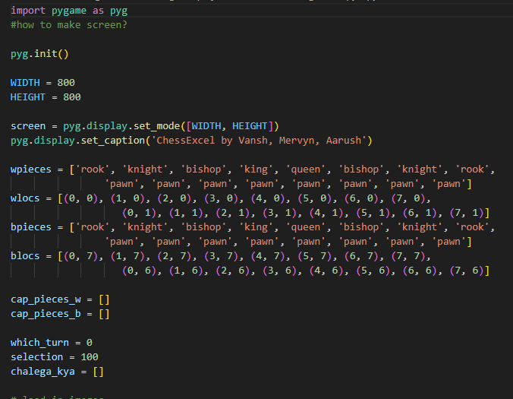

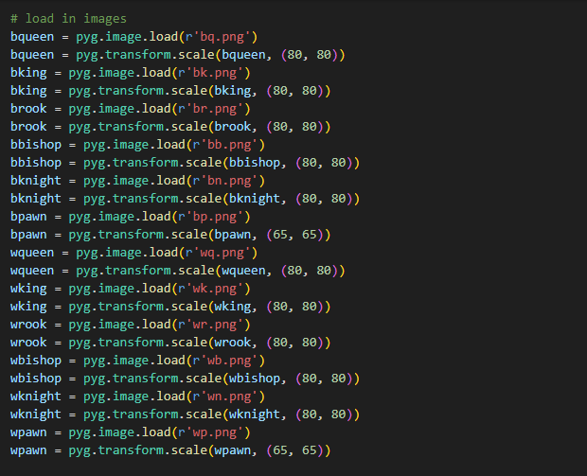

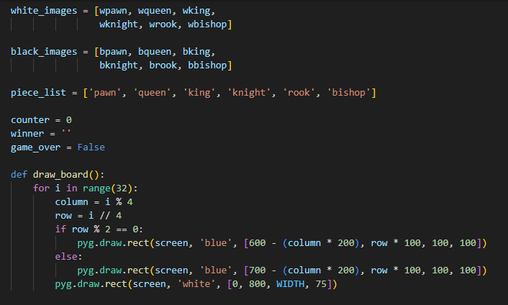

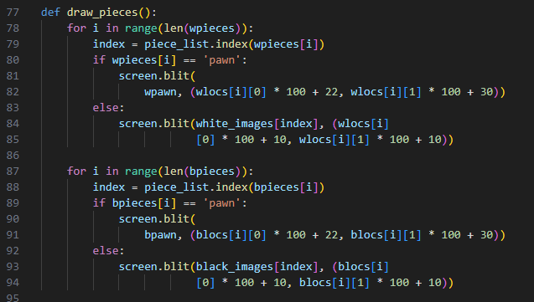

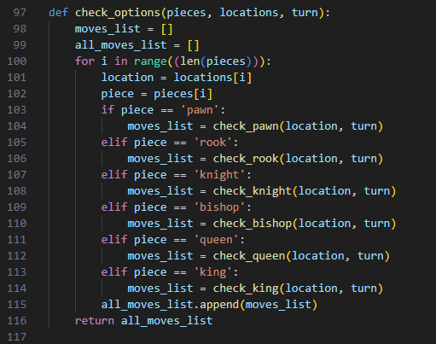

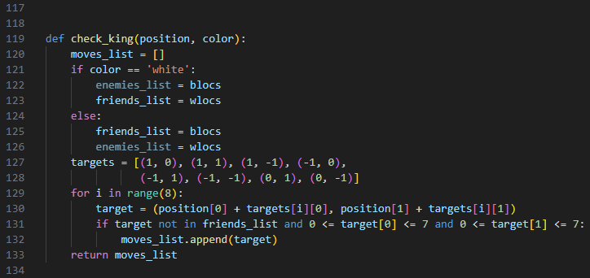

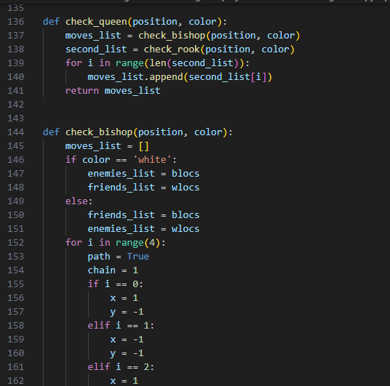

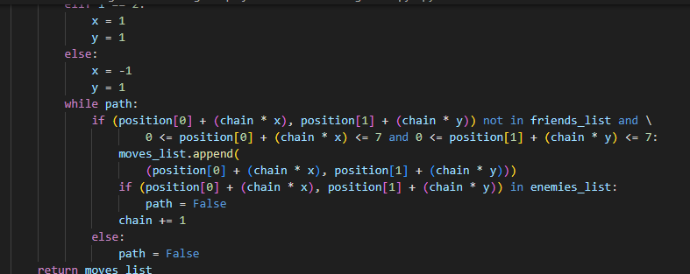

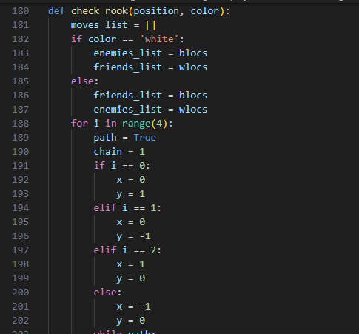

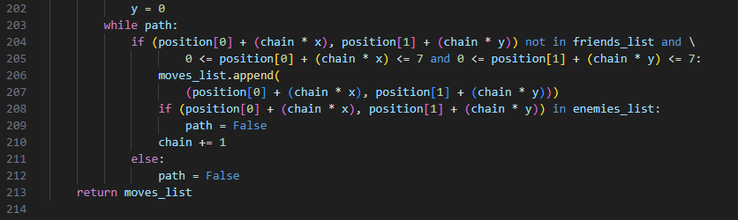

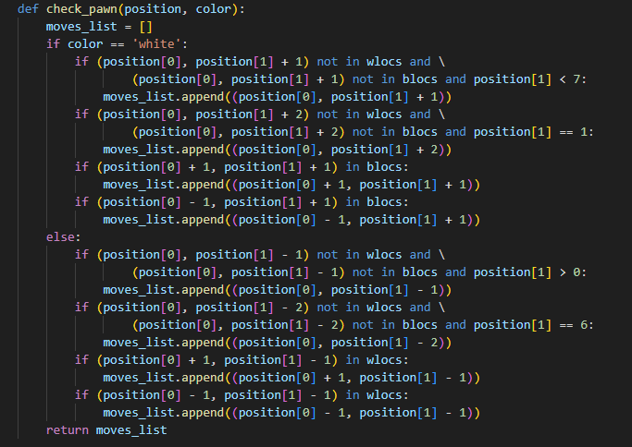

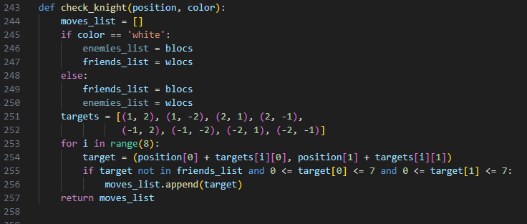

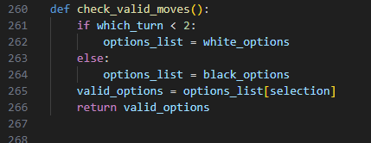

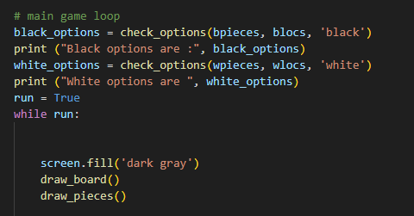

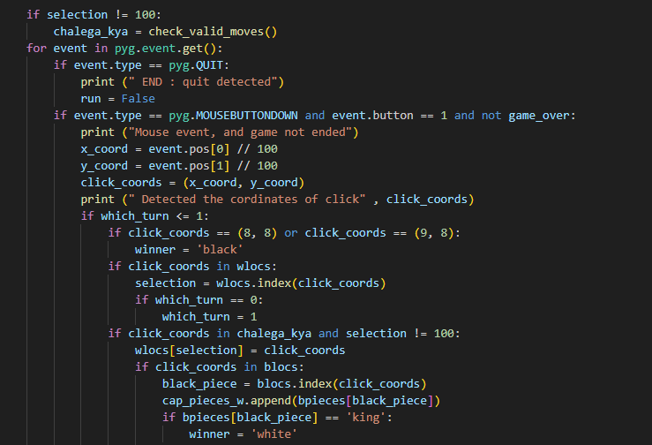

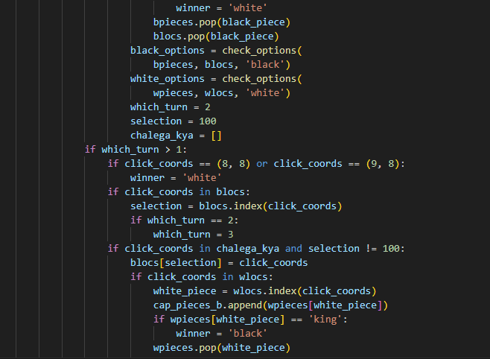

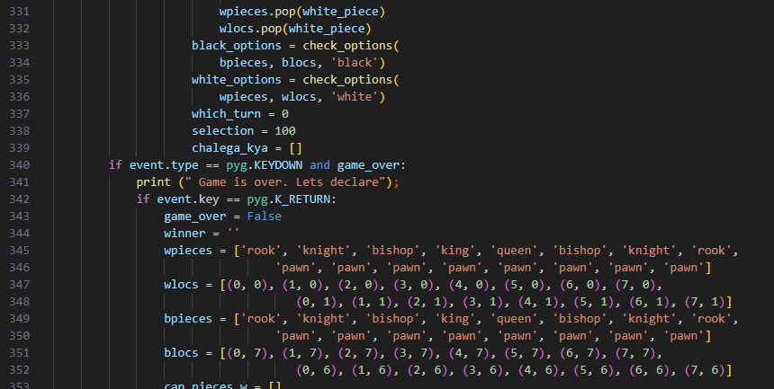

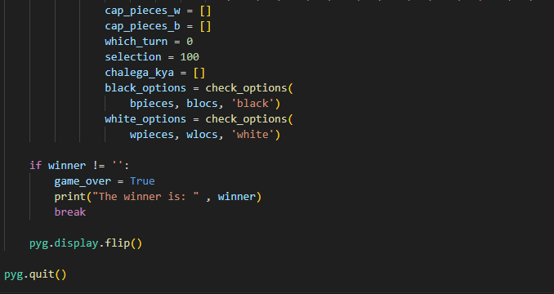

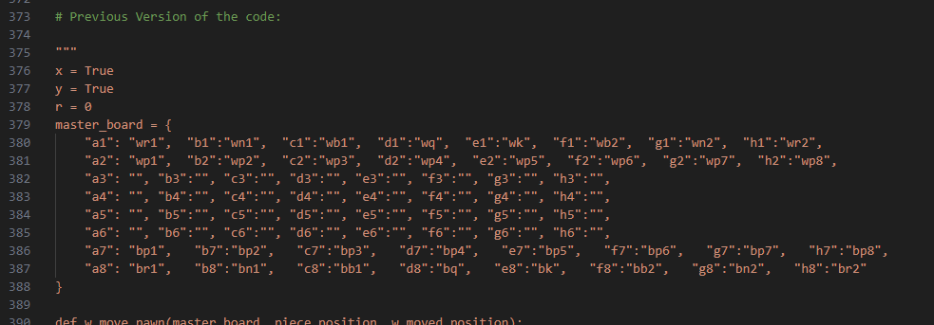

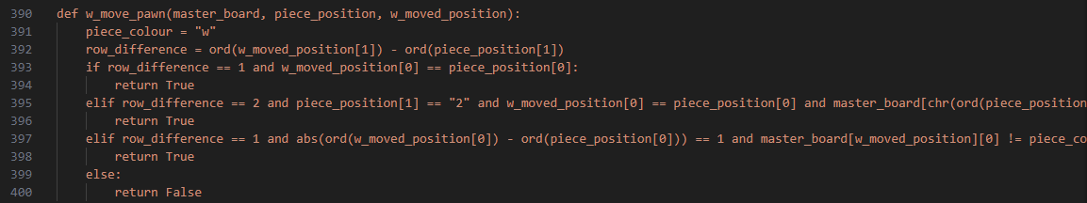

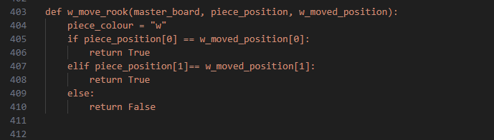

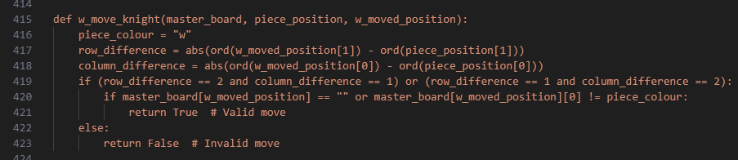

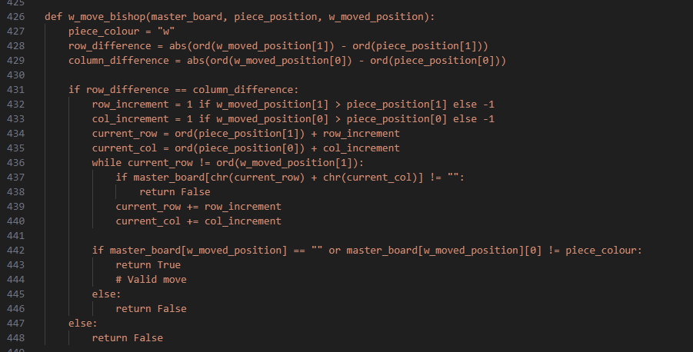

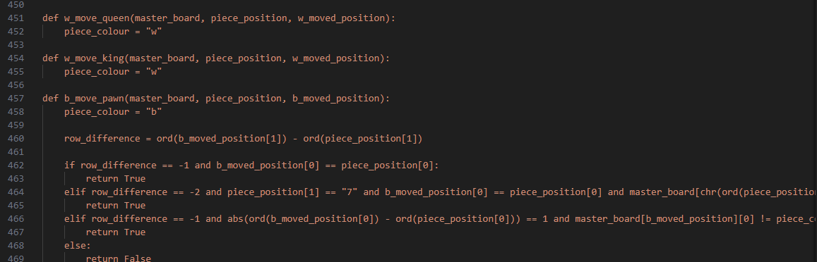

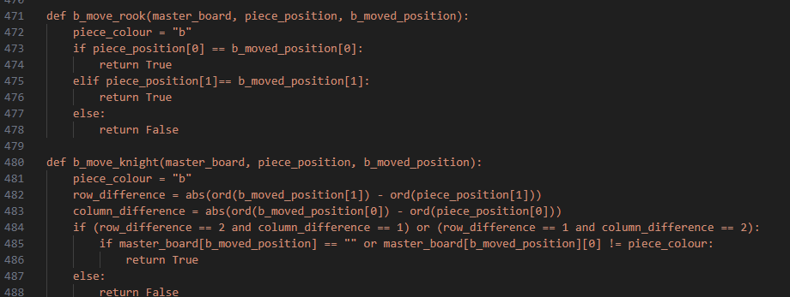

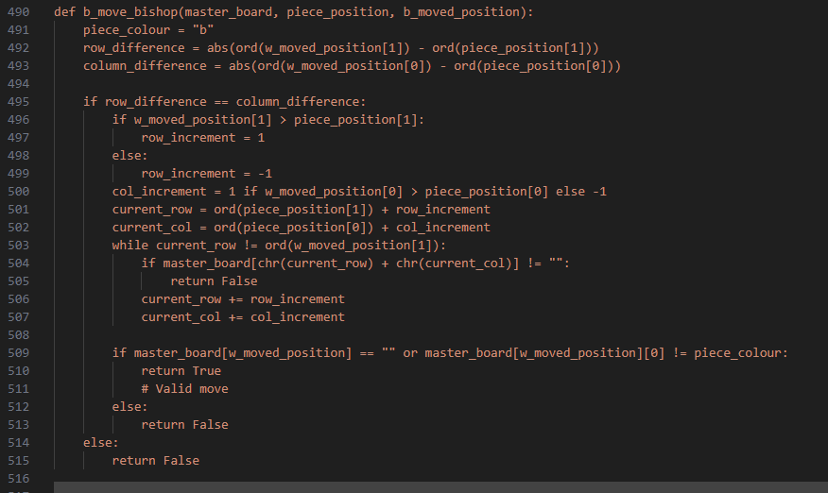

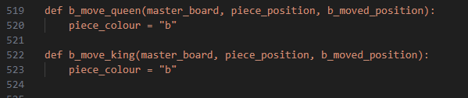

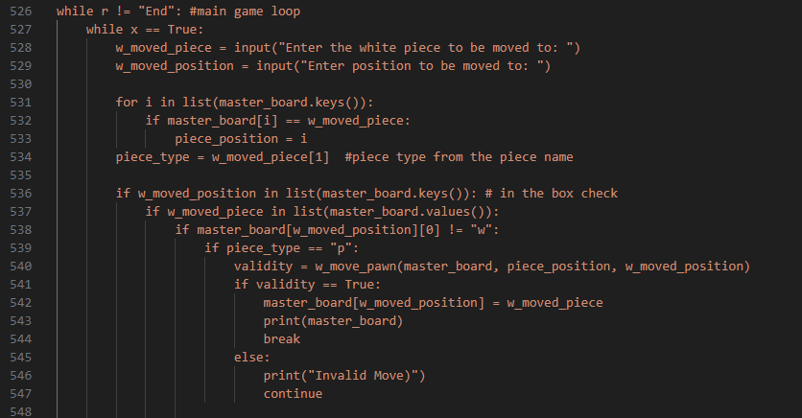

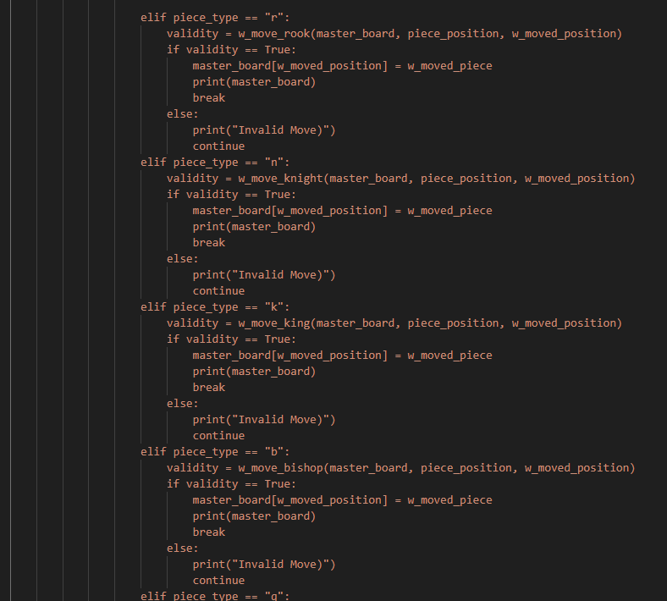

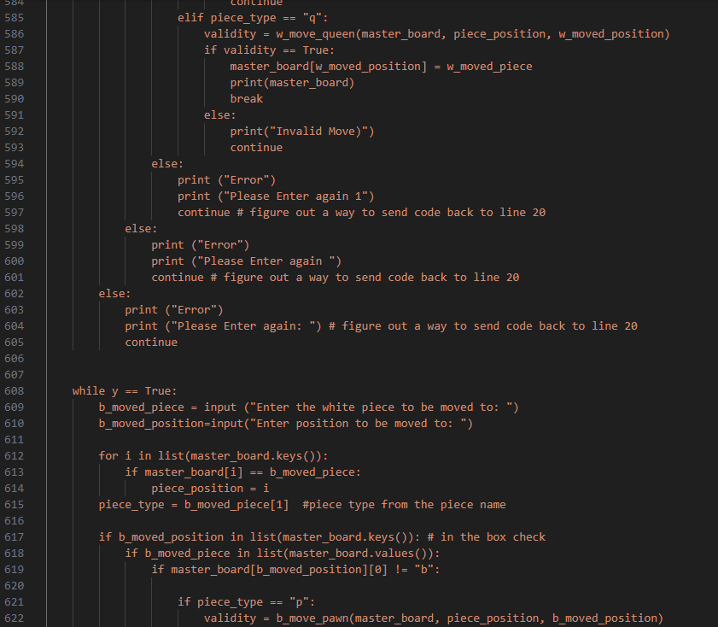

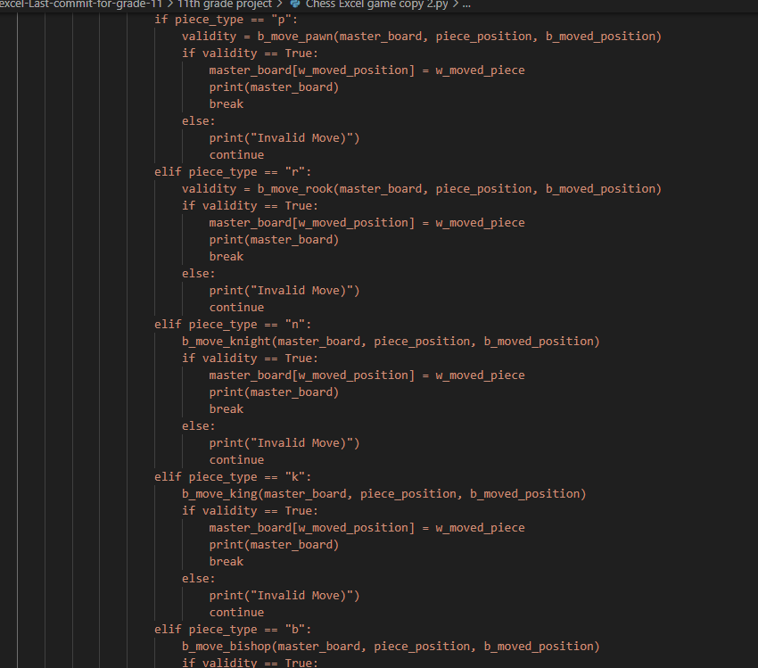

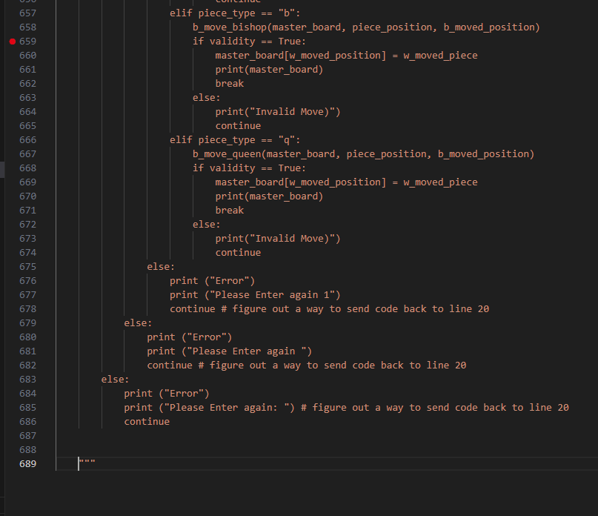

PROGRAM OUTPUT

Start Screen:

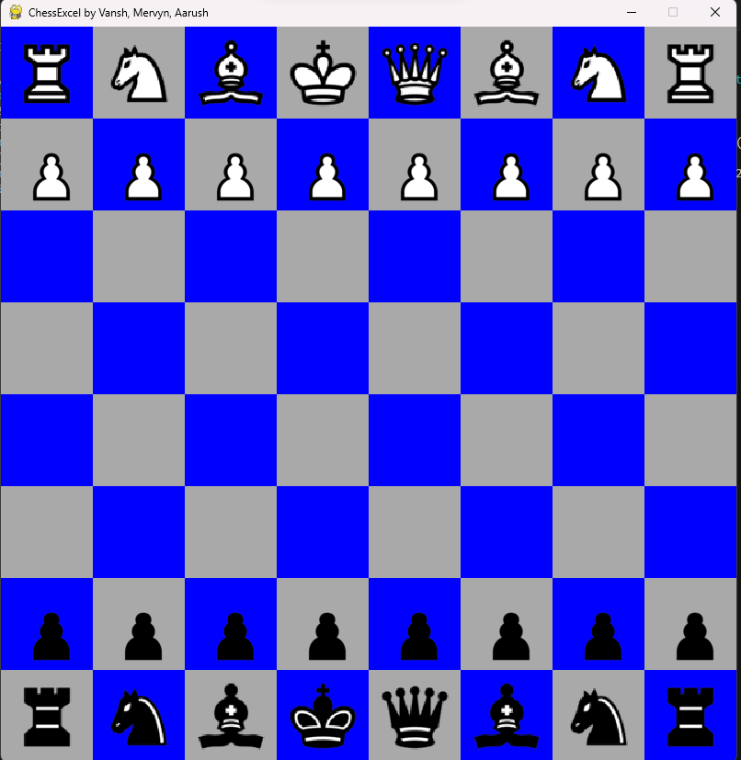

Logging:

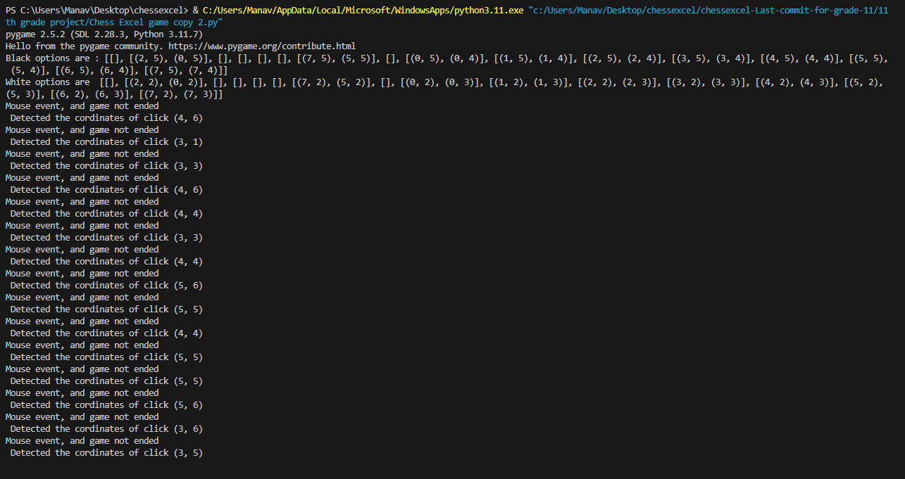

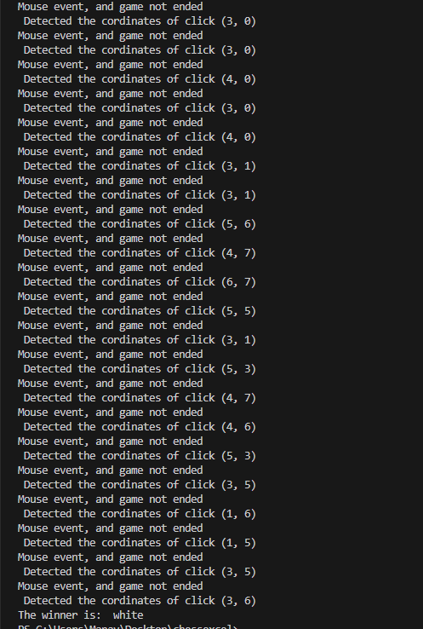

Movement of Pieces:

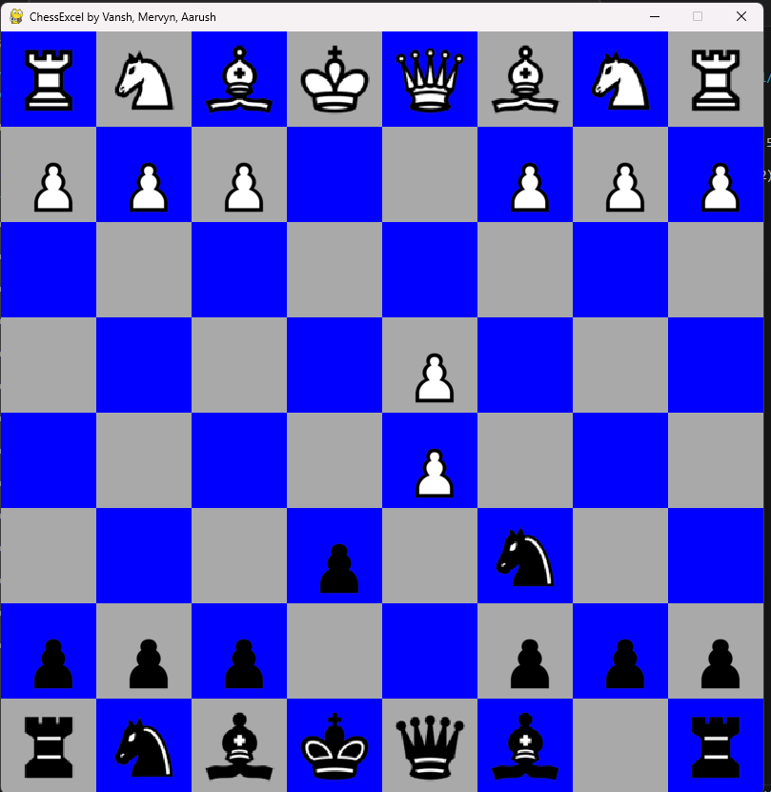

Declaration of Winner:

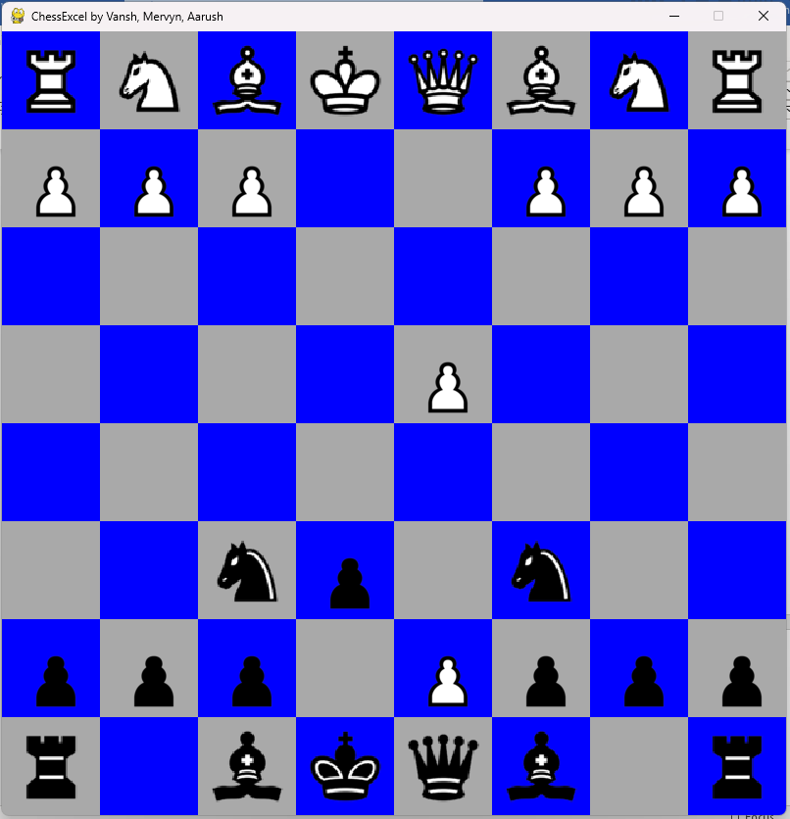

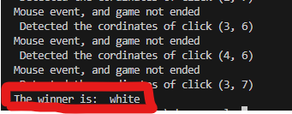

LIMITATIONS AND FUTURE PLANS:

**Limitations:**

1. Single-Player Mode: The current version of ChessExcel only supports a single-player mode, where the player competes against an AI opponent. It lacks support for multiplayer functionality, such as online gameplay or local multiplayer.

2. Limited AI Complexity: The AI opponent implemented in ChessExcel has a basic level of intelligence and may not provide a challenging experience for experienced chess players. Improving the AI algorithm to enhance its strategic capabilities and decision-making process is necessary.

3. User Interface Complexity: The user interface of ChessExcel, while functional, may be considered simplistic compared to modern game interfaces. Enhancements such as improved graphics, animations, and user interactions could enhance the overall user experience.

4. Missing Features: Some essential chess features are missing in the current version of ChessExcel, such as castling, en-passant, and pawn promotion. Adding these features would make the game more comprehensive and enjoyable.

**Future Plans:**

1. Multiplayer Support: Introduce multiplayer support, allowing players to compete against each other online or locally. Implement features such as matchmaking, player rankings, and game lobbies to enhance the multiplayer experience.

2. AI Improvement: Enhance the AI algorithm to make it more challenging and adaptable. Implement advanced techniques such as minimax with alpha-beta pruning, machine learning, or neural networks to create a stronger AI opponent.

3. User Interface Enhancement: Improve the game's user interface by adding visually appealing graphics, animations, and sound effects. Enhance user interactions, such as drag-and-drop piece movement, tooltips, and customizable settings.

4. Additional Features: Implement missing chess features such as castling, en passant, pawn promotion, and undo/redo functionality. Introduce customizable game modes, difficulty levels, and game variants to cater to a broader audience.

**Steps to Achieve Future Plans:**

1. Research and Development: Conduct research on multiplayer networking protocols, AI algorithms, and user interface design principles. Experiment with different techniques and technologies to identify the most suitable solutions.

2. Prototyping and Testing: Create prototypes of new features and functionalities to validate their feasibility and effectiveness. Conduct extensive testing to identify and address any issues or limitations.

3. Community Feedback: Gather feedback from the ChessExcel community, including players, enthusiasts, and developers. Incorporate user suggestions and preferences into the development process to ensure that the game meets their expectations.

4. Continuous Improvement: Iteratively improve the game based on user feedback, technological advancements, and industry best practices. Release regular updates and patches to address bugs, introduce new features, and optimize performance.

**Integration with a Database:**

1. Database Selection: Choose a suitable database technology for storing game data, player profiles, leaderboard information, and other relevant information. Options may include relational databases (e.g., MySQL, PostgreSQL), NoSQL databases (e.g., MongoDB, Firebase), or cloud-based solutions.

2. Database Schema Design: Design the database schema to accommodate the required data structures and relationships. Define tables for storing game states, player profiles, match history, achievements, and other relevant entities.

3. Integration with Python: Use database libraries or frameworks compatible with Python (e.g., SQLAlchemy, Django ORM) to establish connections, execute queries, and perform CRUD (Create, Read, Update, Delete) operations on the database.

4. Data Persistence: Implement mechanisms for persisting game data, such as saving and loading game states, player progress, and configuration settings. Ensure data integrity, consistency, and security through proper error handling and validation.

5. Online Features: Integrate online features such as player authentication, account management, matchmaking, and leaderboards with the database. Implement APIs or web services for communication between the game client and server-side components.

6. Scalability and Performance: Optimize database performance and scalability to handle large volumes of concurrent users, game data, and transactions. Use techniques such as indexing, caching, sharding, and replication to improve responsiveness and reliability.

7. Security Considerations: Implement robust security measures to protect sensitive data, prevent unauthorized access, and mitigate common security threats (e.g., SQL injection, cross-site scripting). Apply encryption, authentication, and access control mechanisms as needed.

8. Monitoring and Maintenance: Set up monitoring tools and procedures to monitor database performance, usage patterns, and potential issues. Perform regular maintenance tasks such as backups, updates, and optimizations to ensure the database remains reliable and efficient.

BIBLIOGRAPHY

1. 1. Adams, J. (2014). "Invent Your Own Computer Games with Python" - A free online book that teaches programming fundamentals using Python and Pygame. Available at: <http://inventwithpython.com/invent4thed/>
2. Swigert, A. (2017). "Pygame Documentation" - The official documentation for the Pygame library, providing comprehensive guides, tutorials, and references for game development with Python and Pygame. Available at: <https://www.pygame.org/docs/>
3. GeeksforGeeks. (n.d.). "GeeksforGeeks - Computer Science Tutorials" - An online platform providing tutorials, articles, and coding challenges covering various topics in computer science, algorithms, data structures, and programming languages, including Python. Retrieved from <https://www.geeksforgeeks.org/>

